

**2024-2025 Family/Student Handbook**

**1162 Richmond Drive**

**Rock Hill, SC 29732**

**Main Office (803) 981-1930**

**Fax (803) 981-1929**

**Nurse (803) 981-1933**

[**http://rd.rock-hill.k12.sc.us/**](http://rd.rock-hill.k12.sc.us/)

**Twitter: @RichmondDrive**

**Facebook: Richmond Drive Elementary School**

**Transportation (803) 980-2022**

**Bushelp@rhmail.org**

**Rock Hill School District Office (803) 981-1000**

## Richmond Drive Elementary School

**Important Phone Numbers**

Mr. Robert Hamm - Principal 803-981-1930

Ms. Kimenya Ramet – Assistant Principal 803-981-1938

Mrs. Tina Davis –Attendance 803-981-1932

Mrs. Morgan Taylor – Accounting 803-981-1933

Mrs. Tami Spain – School Counselor 803-981-1937

Ms. Angie Parkman - Media Specialist 803-981-1936

Ms. Wanda Bankhead– Cafeteria Manager 803-981-1939

– Nurse 803-981-1935

Rock Hill School District Office 803-981-1000

Transportation (School Bus) [bushlelp@rhmail.org](mailto:bushlelp@rhmail.org)

Staff email addresses can be located at <http://rd.rock-hill.k12.sc.us>

Absence / Tardy email - [RDAbsenceDocumentation@rhmail.org](mailto:RDAbsenceDocumentation@rhmail.org)

**Mission Statement for Rock Hill School District Three**

Working together with the students, home, and community, the Rock Hill School District will ensure that all students have the skills, knowledge, and desire to become lifelong learners and succeed in a changing world.

**Core Beliefs of Rock Hill School District Three**

* All individuals have intrinsic worth.
* All individuals can learn.
* Learning depends upon basic needs (physical and emotional) being met.
* Reading is the foundation for unlimited learning.
* An environment where taking risks is encouraged promotes learning.
* Understanding diversity enriches learning.
* Adults can enable students to fulfill their potential by developing positive relationships with them.
* The community is responsible for working interdependently to ensure the welfare of students.
* School will promote lifelong learn

The above beliefs were adopted by the Board of Trustees on November 22, 1993.

**The rules, regulations, and consequences in this handbook are based on policies of the Board of Trustees for Rock Hill Schools. These policies are concurrent with state and federal laws and guidelines. If the district policies, state or federal laws or guidelines are updated, changed, or modified in anyway during the school year, the rules, regulations and/or consequences in this handbook may undergo modifications. Such changes will be posted on the school’s website.**

**VISION for Richmond Drive Elementary**

*Richmond Drive Elementary*

*will empower and inspire each other*

*to take risks in order to achieve at our highest potential.*

**Family Educational Rights and Privacy Act**

Student personnel records are managed in a confidential manner as required by the Family Educational Rights and Privacy Act of 1974 (FERPA). Regulations and procedures for compliance of this act are provided through school board policy JRA. A copy of this policy is on the district's website ([www.rock-hill.k12.sc.us](http://www.rock-hill.k12.sc.us/)) under the link "District Policies."

Photos and Release of Student Information

The following information is released upon request at the discretion of the student’s school principal: The student’s name, address, telephone number, date and place of birth, photo, subjects of study, participation in officially recognized activities and sports, weight and height of members of athletic teams, dates of attendance (on both annual and daily basis), diplomas and awards received, and the most recent previous educational agency or institution attended by the student.

Any parent or guardian of a student attending Rock Hill School District Three who would prefer that any or all of the information designated above not be released without the parent’s or guardian’s prior consent should notify the Office of the Superintendent (P.O. Drawer 10072, Rock Hill SC 29731) in writing. If such notice is given, the school attended by the student must be identified.

**ABCs of Richmond Drive Elementary**

**ADDRESS or PHONE NUMBER CHANGES**

It is important that we always have your current address and phone number. This information is especially important in case of an emergency. Please update changes of address or phone numbers by calling the Richmond Drive office. 803-981-1930

**ARRIVING AT SCHOOL (See additional District Guidelines at the end of the Handbook)**

1. **School Doors Open at 7:00.** Students will be allowed in the building at 7:00. Please do not allow your child to arrive before 7:00 A.M.

2. **Walkers and Car Riders—**Can enter in the front or back of the school.

3. **Bus Riders—**Will be dropped off in the front of the school.

4. If parents need to park and come into the school before school, please **use spaces in the front of the school**. Please do not park cars on the street of Richmond Drive.

5. The **back doors lock** promptly at 7:40am. After this time all students must enter the front door.

6. Students arriving after the **7:45 tardy bell** will need to enter the main office with an adult and signed in by the adult. If a student reaches 10 days tardy, an attendance intervention plan will be put into place.

**ATTENDANCE GUIDELINES**

Students are required to attend school 170 days out of the 180 days school according to SC State Law. Attendance does impact student achievement.

Any student missing school must present a written excuse, signed by a parent/guardian, or a medical excuse. If this excuse is not turned in within **three** days after the student is back in school, the absence will be **unlawful**. The maximum number of days that will be recorded as lawful “written excused” absences with parent notes will be **five**.

Students are considered lawfully absent when:

1. They are ill and their attendance in school would endanger their health or the health of others.
2. There is a death or serious illness in their immediate family.
3. There is a recognized religious holiday of their faith.
4. Activities approved in advance by the principal.
5. The student is suspended out of school.
6. There is a necessary medical or legal appointment that cannot be scheduled during non-school time.

Lawful absences allow students to make up missed work.

**Please note: If your child misses 3 consecutive unlawful/without note or 5 unexcused days, school officials are required to contact the parent for a conference to identify the reasons for the child’s absences and complete an intervention plan to improve attendance.**

The maximum number of days a student is allowed to miss is **TEN** per school year (lawful or unlawful.) When a student is absent more than ten days, attendance will be one of the factors used in the promotion/retention decisions. More than ten absences and/or excessive tardiness could result in a referral to Family Court.

**BREAKFAST**

Breakfast is free for all students and served starting at 7:00am. Car riders and walkers should arrive by 7:30. Students should go straight to the cafeteria when they arrive to pick up breakfast.

**BULLYING**

The board prohibits acts of harassment, intimidation or bullying of a student by students, staff and third parties that interfere with or disrupt a the premises, on a school bus or other school-related vehicle, at an official school bus stop, at a school-sponsored activity or event whether or not it is held on school premises, or at another program or function where the school is responsible for the student. Students should promptly report incidents to an adult (administrator, teacher, counselor, for example), whether they are the victim or a witness to such acts.

The school board has adopted policies on harassment, intimidation and bullying. A copy of these policies can be accessed on under the Parent and Student links on the school website at <http://rd.rock-hill.k12.sc.us> as well as on the Rock Hill Schools website (Policy JIAA, Policy JICFA, Policy JICFAA). Students should promptly report incidents to an adult.

**BUS CONDUCT**

Riding the bus is a privilege and not a right. Students must behave in a safe and orderly manner. The primary goal of the bus driver is to get students home safely. They should be treated with RESPECT.

* Students are expected to sit in assigned seats.
* The bus aisle should remain clear and free of arms, legs, and book bags.
* Students who live outside our attendance zone are not permitted to ride the bus.
* By state regulations, no student is allowed to get on or off the bus anywhere other than their assigned bus stop.
* Major and minor bus offenses will result in write-ups and conferences with administration. Multiple offenses will result in parent conferences. Students who are habitually misbehaving and disrespectful to the bus driver will lose bus privileges. Parents are responsible for transportation when students can no longer ride the bus.
* Issues with transportation should be reported to the Transportation Department and then to school administrators if necessary.
* Transportation changes regarding riding the bus or changing buses MUST be preapproved by the Transportation Department.

### BE GREAT / AFTERSCHOOL PROGRAM

Be Great Academy is an after-school enrichment program for students in 4 year old kindergarten through Fifth grade. It is our pleasure to offer Be Great at all of our district’s elementary schools. We look forward to our working partnership as your child enters our program.

Your child will be served a healthy snack each day and homework/activity time followed by enrichment time. These activities will end promptly at 6:00 p.m. each day. Application Forms are located <https://www.rock-hill.k12.sc.us/Page/8319>.

**CLASSROOM OBSERVATIONS / CONFERENCES**

We encourage parents/guardians to observe or visit their child’s classroom. We ask that you please keep the following district policy (KI-R) in mind:

1. Parent/guardian visits can be made at the teacher’s/school’s invitation or make a formal request to the principal.

2.Classroom visit and/or conference by parent/guardian must be arranged in advance.

3.Classroom observations are at the discretion of the school principal.

4.Building administrator or designee may remain with the parent/guardian during the observation.

5.Observation/conference must be conducted in a manner that the observations do not interfere with the classroom activities.

6.Classroom observation should not last longer than 20 minutes.

7.Conferences are an essential part of the education program. It is important to keep parents/guardians in close contact with the child’s progress. Parents may request a conference by contacting the teacher.

**COMMUNICATION BETWEEN SCHOOL AND HOME**

Open House / Meet the Teacher is held the week before school starts. Communication receives strong emphasis at Richmond Drive Elementary. Information is sent to parents each Wednesday in a red folder as well as through text and email. When papers come home with unsatisfactory grades or with notes that assignments were not completed, please communicate with your child's teacher.

We welcome your questions and input. You can access school information from these sources as well:

**CANVAS** – 3rd – 5th grade communication platform

**SeeSaw** – K5 – 2nd grade communication platform

**Website--** [**https://www.rock-hill.k12.sc.us/Domain/21**](https://www.rock-hill.k12.sc.us/Domain/21)

**Facebook**—“Like” us at Richmond Drive Elementary

**Twitter**—@richmonddrive #rdesthedrive

**Instagram** - RichmondDrive_Tigers

**District App**—Go to the App Store and download it for free. Be sure to select Richmond Drive in order to receive communications.

**Richmond Drive Update (S’more Newsletter:** —Newsletters are emailed and textsent weekly to families. The newsletter can be accessed at the sites above.

**DISMISSING FROM SCHOOL AT END OF DAY**

1. Students will be dismissed at 2:10 P.M.

2. **Early Releases**—Early dismissals (parent pick-up/student sign-outs) end at **1:45** unless he/she has a doctor’s appointment or there is an emergency. It is difficult for our school to safely dismiss all students to their proper locations if there are exceptions to how they go home.

3. **Car Riders—**Will be picked up in the designated area in the **back** of the school that can be accessed using the traffic loop by the playground from Richmond Drive or from McDow Street.

**Bus Riders—**Will be picked up at the front of the school.

**Van Riders—**Will be picked up in front of the school near the PE room.

**Walkers—**Will be escorted out the back and front of the school with staff members.

Walkers should use sidewalks and should cross only where adults are located.

4. All parents should wait in the car line to pick up their child. Place a pickup card on your dashboard with the students’ names.

5. Please let your child’s teacher know how he/she will be going home each day and how he/she will go home on inclement weather days. **Dismissal changes should be made in writing**. **NO** changes will be made after 1:45 pm.

6. Bike riders are to leave school grounds at dismissal with staff. Bike riders should lock their bike in front of the school.

**DISCIPLINE**

It is necessary for children to develop self-discipline to further their learning. We ask you to discuss with your child the importance of and need for good behavior and positive attitude while at school. When necessary, teachers / principals will contact parents/guardians to discuss situations as a team. Our goal is to help the child be successful.

Minor Referrals are for behaviors that are managed in the classroom for behaviors that are disrupting the learning of the child or others. Parent will be contacted by the teacher.

Major Referrals are for severe incidents where a student needs to be removed for such events as: fighting, bullying, threats, or destruction of property.

If a student receives a major referral, possible consequences may include:

* Student conference with principal
* Parent conference with principal
* Loss of privilege
* Suspension from school

As the parents, Richmond Drive strives to work together with you as a team. We all want what’s best for the children. Please plan to partner with us for a successful year.

**DRESS CODE**

Students are expected to dress in a manner that does not distract from learning. Parents will be called to bring suitable clothing if students come to school dressed inappropriately. Please make sure your child is dressed appropriately for weather conditions.

* Messages and pictures on t-shirts must be suitable and age appropriate.
* Tank tops should be at least 3 fingers wide.
* No halter tops.
* No low cut tops.
* No short shorts, short dresses, or short skirts.
* No pants below the hips. Belts are to be worn to keep them up.
* No pants with holes or cut-outs.
* Leggings can be worn with dresses or skirts, but not with t-shirts.
* No flip flops or high heeled shoes. These are not safe in the hallway in the event of an emergency.
* Head coverings are not allowed except for religious reasons (scarves, stocking caps, hoods, hats, ears, towels, sunglasses, bandanas, etc.) or for school spirit days (which will be made known to families in advance).
* Shorts/skirts/dresses must be fingertip length without pulling and adjusting.
* Costumes and furry outfits, tails, footwear, ears, and any related accessories are not permitted on campus.

**EMERGENCY DRILLS**

Emergency drills are necessary for the safety of students and staff. Procedures are practiced throughout the year. Specific information for emergency drills is posted in each classroom. In the event of radiation, students will be transported by school bus to designated areas.

### FOOD SERVICE / Cafeteria

The Rock Hill School District 3 of York County offers healthy meals every school day and menus are sent home monthly or can be accessed on the district website at [**https://www.rock-hill.k12.sc.us/domain/292**](https://www.rock-hill.k12.sc.us/domain/292)**.**

**GIFTED AND TALENTED**

The GT program is designed for students in grades 3-5 who qualify using the State Department of Education regulations as academically gifted/talented. This program provides participating students educational experiences which meet their special talents and abilities. The program emphasizes research skills, critical and creative thinking skills and communication skills through the exploration of problem based curriculum built around a broad concept. Students are grouped in multi-aged classrooms. Group projects, individual projects, simulations and resource speakers are integral parts of the program.

Rock Hill School District follows established guidelines mandated by the State Department of Education to determine student eligibility for the program. To see if your child might qualify for the program, please contact Mr. Wilson, Assistant Principal.

**HOMEWORK**

Homework is a practice of skills previously learned. Each child is expected to **read every night**. It is important that you read to/with your child daily. Please stress to your child that he/she should clarify assignments, directions, and procedures for doing homework before leaving school.

You may contact teachers through SeeSaw (K-2nd grades) or CANVAS (3rd – 5th grades) programs.

**MEDICAL ISSUES AND EMERGENCIES**

**Accidents**-- Every effort is made to prevent accidents. If an accident occurs, the procedure will be as follows: First aid will be administered by authorized school personnel. A parent will be called if the accident or illness is considered serious, if the child is uncomfortable or has fever. If we cannot reach a parent, the school will follow the parent's directions of emergency contacts to secure an individual to pick up the child or to secure emergency medical treatment if needed.

**Immunizations--**The state of South Carolina requires that all children entering K5-12th grades have the hepatitis B series. In addition, all children entering K5-3rd grades are required to be vaccinated against chickenpox or have a documented history of chickenpox disease. All students are required to have a South Carolina certificate of immunization as part of their school records.

**MEDICATIONS— Medications may not be given at school without a doctor’s order. For over the counter (OTC) medications, parent permission is required. If it is necessary for a child to receive over the counter medications, parents must submit a completed permission form. Without this district OTC form a parent would come to the school and administer the medication.**  **All medications need to be in their proper prescription bottle and you must fill out a school permission slip with the office. CHILDREN ARE NOT ALLOWED TO CARRY ANY MEDICATIONS INCLUDING OVER THE COUNTER MEDICINES ON THEIR PERSON AT SCHOOL.** Parents should pick up any unused medication at the end of the year. Office staff will notify the parent and teacher when a student who is taking medication is in need of a refill of that medication. Medical information: <https://www.rock-hill.k12.sc.us/site/Default.aspx?PageID=765>

**Screenings--**During the course of the school year, the nurse will be conducting vision and hearing screenings on K5, 1st, 3rd, and 5th graders. If you are a parent of a 2nd or 4th grader and you have concerns about your child needing to be screened for vision and / or hearing let me know and the nurse will be happy to screen them.

**Contact Information--**In case your child is ill or injured while at school it is very important that we have current home and work numbers so we can contact you. If your telephone numbers change, let the office know as soon as possible. If your child is out for more than one day with an illness please give your child’s teacher or the office a call. We love and care for our students and we miss them when they are not here!

# 

**PICTURES**

School pictures are taken twice a year, in the fall and again in the spring. Pre-payment will be required to order pictures. If a student is on the “do not photo” list, he/she will not have their photo taken and will not appear in the yearbook.

**PLAYGROUND**

Recess times for each grade level will be determined at the beginning of the year. If teachers choose to take children out at a time other than their scheduled time, they must request permission from administration. Outside recess time is determined by the weather. On extremely cold or hot days, recess may take place in the building.

**POSITIVE BEHAVIOR INTERVENTION AND SUPPORT (PBIS) and DISCIPLINE**

We are the TIGERS of Richmond Drive. As a school community we must be safe, respectful, responsible, and prepared. Students and staff are expected to show positive behaviors to include the TIGER traits: talent, inclusion, gratitude, excellence and respect. All students will be acknowledged for the positive behaviors displayed at school by hearing compliments and daily praise from staff and supportive peers. PBIS offers a framework for explaining and encouraging school wide expectations. Weekly TIGER stripes are given as a token of randomly observed TIGER traits.

Positive behavior is our priority and expectation at Richmond Drive Elementary. Teachers will practice routines and procedures to lessen distractions and disruptions so there is quality instruction for all students in an environment, which is conducive to learning.

We agree that:

1. Teachers have classroom expectations with positive and negative consequences.
2. Reteaching of expectations will be a part helping students understand the expectations.
3. Teachers will communicate on a regular basis pertaining to student behaviors in the classroom.

4. Student behavior intervention plans will be established when needed.

If a referral is completed for misbehavior, the parent will be contacted by the teacher. Parents should sign and return the school copy of the discipline referral form.

**Minor Referral-** Behavior was addressed byclassroom teacher/staff and interventions are considered and/or implemented. Parent contacted by teacher.

**Major Referral-** Behavior required administrator’s attention and possible removal from the classroom.

All school personnel are trained annually on emergency preparedness/district procedures and protocols through SafeSchools videos. Additionally, best practices for de-escalation of behavior and staff training for trauma informed is available through 321 Insights videos.

**PROHIBITED ARTICLES**

Students are not to bring radios, beepers, tape players, electronic games, balls, or toys to school. These items will be confiscated. Cell phones should be turned off and stay put away in bookbags during the school day.

The following articles may not be brought to school because they are hazards to the safety of others or may interfere in some way with school procedure:

Toy guns, knives, firecrackers, razors, razor blades, caps, Martial Arts weapons, or pornographic materials. Such items will be taken from the student and under no circumstance will be returned to the student. If parents wish to reclaim the items, they may come to the school for them. Students having hazardous articles or articles that interfere with school procedures are subject to disciplinary action. Students who bring weapons and/or drugs on school grounds will be suspended and the proper authorities will be notified for possible legal action.

**PTO**

Richmond Drive School enjoys a very active Parent-Teacher Organization.

The goals are:

1. To promote the welfare of children in the home, our school, and

our community.

2. To bring into closer relation the home and the school so that

parents and teachers may work together for the education of

our children.

Some of the activities that PTO has funded and coordinated may include: Tiger Trot, Book Fairs, Breakfast with a Buddy, Red Ribbon Week, Field Trips, and Teacher Appreciation.

**REPORT CARDS**

A child's report card is as personal and individual as the child. It is best not to compare report cards among children in the family or in the neighborhood. Since children do not develop or learn at the same rate, attempts are made to understand how your child learns best and to teach him/her at his/her level and rate of learning by using appropriate materials. Report cards are sent at the end of each nine weeks. Report cards are also available via parent portal.

If you have questions about your child's work, progress, grades, or other concerns, please call the school to schedule a conference.

**SCHOOL CLOSING AND DELAYED OPENING DUE TO BAD WEATHER**

**PLEASE DO NOT CALL THE SCHOOL** Often our lines are tied up, and we are not able to receive the information we need. Parents can find information about school openings and closings due to bad weather at the school district information line (366-INFO or 366-4636) or the district’s website ([www.rock-hill.k12.sc.us](http://www.rock-hill.k12.sc.us)) or local radio and TV stations. Information will also go out on the Rock Hill Schools District App. We will also send out a telephone message when there are closings or delays. Please make tentative plans to deal with early dismissal or late arrival situations in advance.

**SCHOOL COUNSELOR SERVICES**

The School Counselor is available to speak with any student. She works carefully within the school to support a caring culture at Richmond Drive. Parents, teachers, staff or students may request the school counselor’s involvement for a student who is in crisis or in need of short-term social/emotional counseling. Guidance class is taught to all students on a regular basis. Guidance curriculum includes lessons to enrich students’ academic learning, personal/social development and career exploration and awareness. She works closely with the Rock Hill Schools’ mental health counselors to provide long-term, therapeutic mental health services for students and families.

**SCHOOL IMPROVEMENT COUNCIL**

This council shall include at least two parents elected by the parents of the children in the school, at least two teachers elected by the faculty, and two other representatives appointed by the principal. The elected members of the committee shall comprise at least two-thirds majority of the membership of the committee. All meetings are open to anyone interested.

**SCHOOL SUPPLIES**

Please see that students have pencils, paper, notebooks, and other supplies needed. Find recommended items on the Rock Hill School Website. <https://www.rock-hill.k12.sc.us/domain/1637>

**SCHOOL-WIDE EXPECTATIONS**

1. No gum

2. No hats or hoods on shirts may be worn in the building

3. All adults and children in the building will be treated with respect

4. No profanity

5. No fighting or vandalism of property

6. All visitors must check in with the school office and obtain a visitor's

pass which should be returned to the office upon leaving the school.

7. All persons on school grounds will practice good manners

and show good citizenship.

**TARDINESS AND LEAVING EARLY**

**Tardiness**--Students who come to school late lose valuable learning time, interrupt the class, and miss important explanations of the work to be done. Students who are late must be signed in the office in order for attendance to be corrected. Failure to sign in creates problems for the student as well as the school. Tardies are reported on the report card unless the tardy is caused by a late bus. **Students arriving after 7:45 A.M. will only be admitted through the front door and need to sign in at the office with an adult entering the office.**

**Leaving Early--**No student will be allowed to go home a different way unless permission is requested by a parent/guardian in writing. Students not assigned to a bus are not allowed to ride the bus without permission from the Director of Transportation. No student will be permitted to leave the campus early unless a parent/guardian comes to the office to sign the student out. A request to have a child excused from classes early should be sent **in writing** with the child on the morning of the dismissal. The time and reason for leaving should be included. When possible, medical and dental appointments should be made after school hours. Early dismissals should be limited and the office notified the morning of the early dismissal. Students will be signed out in the office.

**TEXTBOOKS**

Students do not pay an annual book fee; however, they are expected to take good care of all textbooks. Books that are lost or damaged must be paid for by the guardian of the student.

**TRANSFERS**

When parents find it necessary to withdraw their child from school, they should notify the office and homeroom teacher before their last day of attendance. All textbooks and library books are to be returned on the student's last day of attendance and the student is to take all personal items from his/her desk and cubby. All financial obligations must be settled before the student transfers. When a student enrolls in his/her new school, the new school will contact Richmond Drive and the student’s records will then be sent to the new school.

**VISITORS**

Visitors who are on school business are welcomed at school; however, immediately entering the school grounds, all visitors will "check in" at the school office, state the nature of their business, and be assigned a visitors' badge which must be worn throughout the building. Failure to comply with the check-in procedure will result in the visitor being asked to leave the campus. After this warning, the police will be called and the violators will be prosecuted. All visits to the classroom must be scheduled in advance. While we encourage parents and family members to eat lunch with their child, we ask those visits be limited to once-a-week. This enables our children to develop good relationships with each other and helps foster community within the class.

In-district students will not be allowed to visit between schools of the district. Students who do so may be charged with trespassing and/or recommended for expulsion from the district schools.

**VOLUNTEERS**

Research indicates that students who have family members that volunteer in schools achieve more than those who don’t. We welcome any volunteers and will assist however needed in choosing an area in which to participate. We can match a volunteer’s gifts and talents with areas of need in our school. To name just a few ways to help, volunteers can assist in the library, help the classroom teacher with activities or projects sponsored by the PTO, tutor students or assist with special activities. We **strongly** encourage parents/guardians and grandparents to share their time and talents with us. **All volunteers must complete a Volunteer Screening Form every two years.** You can do this at <https://www.rock-hill.k12.sc.us/Page/1188>

**YEARBOOKS**

School yearbooks are sold in the fall and spring then delivered to students at the end of the year. Please remember, any student that is on the “do not photo” list will not have their photo taken and it will not be published in the yearbook.

**Elementary Transportation -Arrival & Dismissal –District Guidelines**

In accordance with State Law 59-67-420, “the State, acting through the State Board of Education, assumes no obligation to transport any student to or from school who lives within one and one-half miles of the school he attends, nor to provide transportation services extending within three-tenths of a mile walking distance of the residence of any student.” If a student resides in a no transportation zone, the parent or guardian is responsible for providing transportation to and from school.

The school will only accept handwritten notes for any non-emergency changes to dismissal. The District understands that emergencies take place. Therefore, when these extreme situations occur, the parent/legal guardian will need to call the school. The school must be able to verify the parent/legal guardian’s information before accepting a change to transportation for emergencies. When the school is not able to verify emergency changes to transportation the school will keep the student until the parent/legal guardian, or an authorized person on the student’s information card can pick the student up. The decision to allow the emergency transportation change is at the sole discretion of the principal or his/her designee.

**Walkers/Bike Riders**

We want to emphasize the importance of student safety, especially with our walkers and bike riders. It is each parent/legal guardian’s responsibility to instill the importance of safety and appropriate behavior for students as they travel to and from school. In the event of an emergency that takes place off campus, please call 911 to alert authorities.

Parents or legal guardian of students that walk to school will need to complete an approval form for their student to walk home (Attachment A) and this form will be kept on file at the school. Students in grades Kindergarten through first grade will not be allowed to walk home without a parent/legal guardian, older sibling, or an approved person on the student’s emergency card meeting them at the school. Anyone other than an older sibling meeting a Kindergarten through first grader will need to have the student’s walker pass in order to receive the walker.

On severe weather days, it is at the discretion of administration as to whether the students will be released or held at school. In the event of lightning, hail, tornado warnings, students will be held on campus, and parents will be contacted with specific information regarding release or pickup of students.

**Car Riders**

All car riders are to only be picked up and dropped off from the designated school pick up area. Students should not be encouraged to be picked up from areas outside of the school drop off and pick up areas. Students will only be released to individuals that have the student’s car pass. Car passes will only be issued to those individuals that the parent/legal guardian has included on their student information card as being able to pick up their student. If a student is to be picked up by someone without a car pass then he/she must park and sign the student out from the main office.

**Bus Riders**

Any changes to transportation plans will need to be made in writing to the school. Only handwritten notes will be accepted for transportation changes. Students will not be released off the bus for grades Kindergarten and first unless an authorized adult is present at the bus stop. Any student that is not dropped off will be returned to their home school.

Contact the bus office at [bushelp@rhmail.org](mailto:bushelp@rhmail.org)

Transportation Information: <https://www.rock-hill.k12.sc.us/Domain/303>

**District Information and Policies**

District Policies Link

<https://boardpolicyonline.com/?b=york3_rock_hill>

**Notification of Rights under FERPA for**

**Elementary and Secondary Schools**

The Family Educational Rights and Privacy Act (FERPA) affords parents and students over 18 years of age ("eligible students") certain rights with respect to the student's education records. These rights are:

1. The right to inspect and review the student's education records within 45 days of the day the school receives a request for access. Parents or eligible students should submit to the school principal [or appropriate school official] a written request that identifies the record(s) they wish to inspect. The school official will arrange for access and notify the parent or eligible student of the time and place where the records may be inspected.

2. The right to request the amendment of the student’s education records that the parent or eligible student believes are inaccurate, misleading, or otherwise in violation of the student’s privacy rights under FERPA. Parents or eligible students who wish to ask the school to amend a record should write the school principal [or appropriate school official], clearly identify the part of the record they want changed and specify why it should be changed. If the school decides not to amend the record as requested by the parent or eligible student, the school will notify the parent or eligible student of the decision and advise them of their right to a hearing regarding the request for amendment. Additional information regarding the hearing procedures will be provided to the parent or eligible student when notified of the right to a hearing.

3. The right to privacy of personally identifiable information in the student's education records, except to the extent that FERPA authorizes disclosure without consent. One exception, which permits disclosure without consent, is disclosure to school officials with legitimate educational interests. A school official is a person employed by the school as an administrator, supervisor, instructor, or support staff member (including health or medical staff and law enforcement unit personnel); a person serving on the school Board; a person or company with whom the school has outsourced services or functions it would otherwise use its own employees to perform (such as an attorney, auditor, medical consultant, or therapist); a parent or student serving on an official committee, such as a disciplinary or grievance committee; or a parent, student, or other volunteer assisting another school official in performing his or her tasks. A school official has a legitimate educational interest if the official needs to review an education record in order to fulfill his or her professional responsibility.

4. Upon request, the school discloses education records without consent to officials of another school district in which a student seeks or intends to enroll or is already enrolled if the disclosure is for purposes of the student’s enrollment or transfer. [NOTE: FERPA requires a school district to make a reasonable attempt to notify the parent or student of the records request unless it states in its annual notification that it intends to forward records on request.]

5. The right to file a complaint with the U.S. Department of Education concerning alleged failures by the school to comply with the requirements of FERPA. The name and address of the Office that administers FERPA are:

Family Policy Compliance Office

U.S. Department of Education

400 Maryland Avenue, SW

Washington, DC 20202-8520

**Directory Information**

The following information is releasable upon request at the discretion of the principal of each school: the student’s name, address, telephone number, date and place of birth, photo, subjects’ study, participation in officially recognized activities and sports, weight, and height of members of athletics teams, dates of attendance (on both an annual and daily basis), diplomas and awards received, and the most recent/previous educational agency or institution attended by the student. Any parent or guardian of a student attending Rock Hill Schools who would prefer that any of the information designated above not be released without the parent’s or guardians’ prior consent should notify in writing the Office of the Superintendent, Rock Hill Schools P.O. Drawer 10072, Rock Hill SC 29731 by the Tuesday following Labor Day. If such notice is given, the school attended by the student will be notified.

**Guidelines for Implementing Student Attendance Regulations**

**School Year 2022-23**

Any student who misses school must present a written excuse, signed by a parent/guardian, or a medical or legal statement. If a written excuse or medical/legal statement is not provided to your school’s Attendance Office within *three* days after the student is back in school, this absence will be unexcused. The maximum number of parent notes accepted and recorded for illness as a lawful/excused absence is *five* per school year.

Students will be considered lawfully excused absent when:

1. a. They are ill and their attendance in school would endanger their health or the health of others.
2. b. There is a death or serious illness in their immediate family — with proper documentation (bulletin, death notice, etc.).
3. c. There is a recognized religious holiday of their faith.
4. d. Activities approved in advance by the principal.
5. e. The student is suspended from school.
6. f. There is a necessary medical or legal appointment that cannot be scheduled during non-school time.
7. g. Absences associated with Covid-19,

*Lawful absences allow students to make up missed work.*

Note: Out-of-town trips/vacations are not lawfully excused absences.

Early Dismissal: Students are not allowed to leave school after 1:45 p.m. UNLESS a doctor's excuse/appointment card is presented to the office by the parent at the time of dismissal. In addition, no transportation changes can be made AFTER 1:45 p.m.

Student Attendance Intervention Plans

After three consecutive or a total of five unlawful absences, regulations require that school officials contact the parent/guardian for a conference. The purpose of this conference is to identify reasons for your student's absences and to complete a Student Attendance Intervention Plan.

The maximum number of days a student is allowed to miss is TEN per school year (lawful or unlawful.) When a student is absent more than 10 days, attendance is a key factor used in the promotion/retention decisions for grades K-5.

*Citation: South Carolina Code of Laws 59-65-50, 60 & 70, and South Carolina Board of Education Regulations.*

**Student Transportation Regulations**

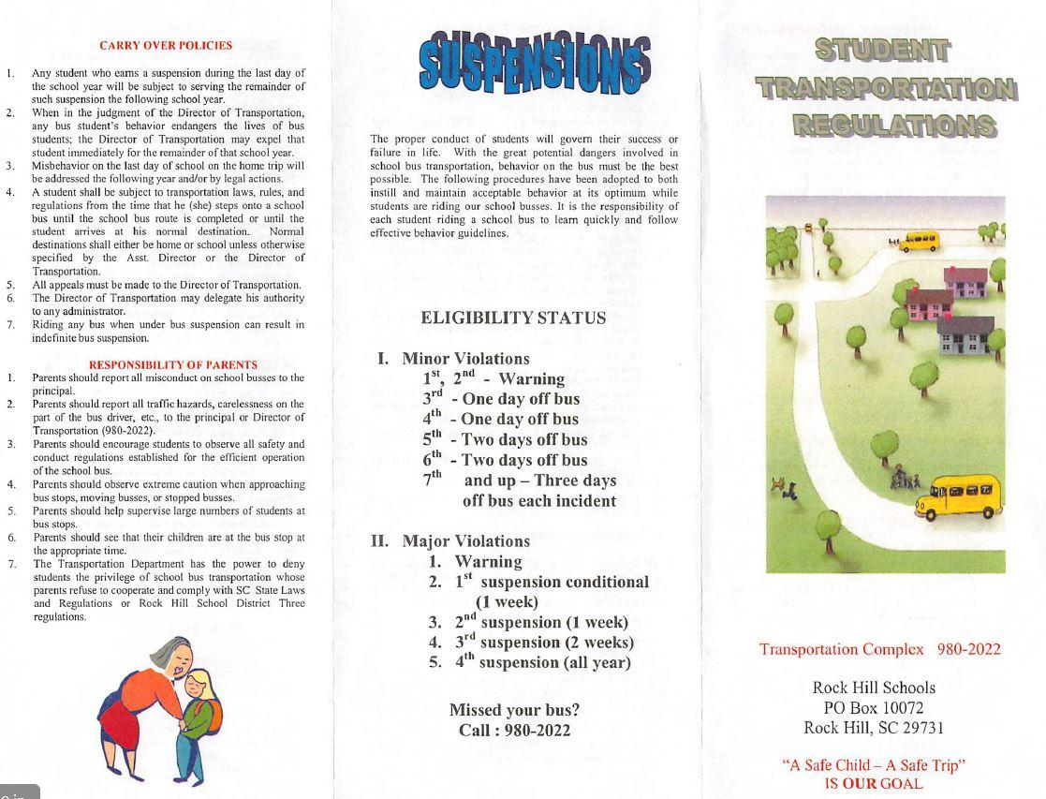

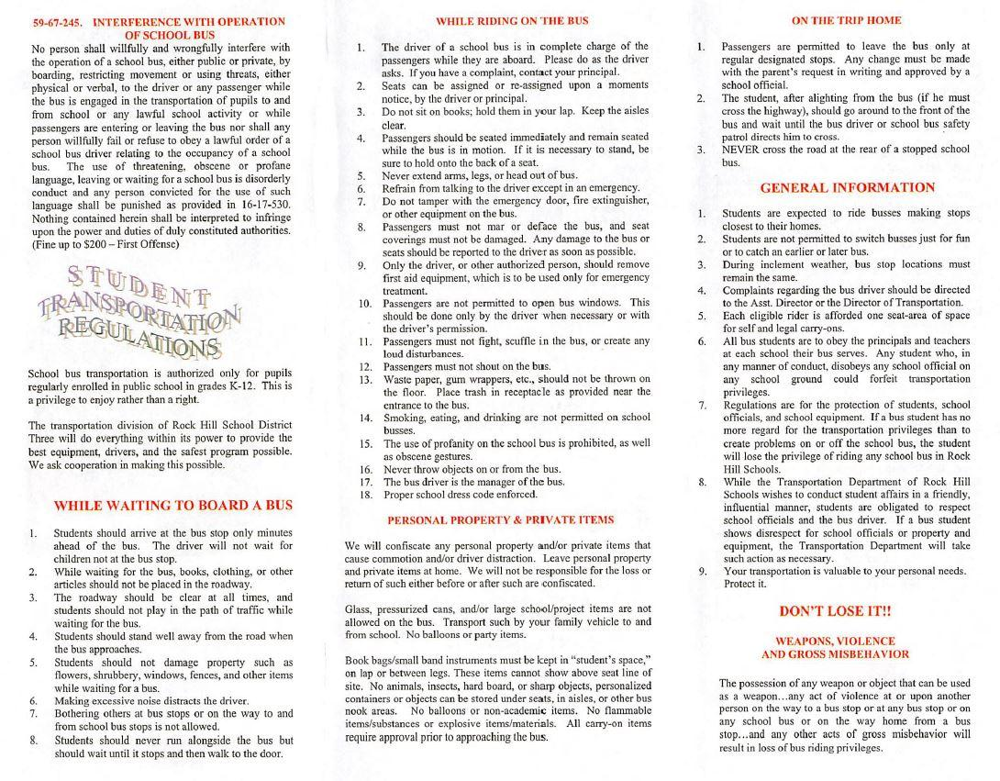

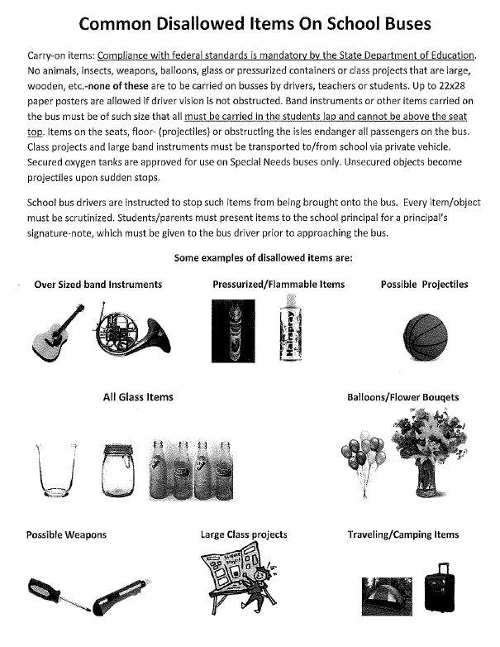

**Policy JICFAA Harassment, Intimidation or Bullying**

Issued 1/16

Purpose: To establish the basic structure for maintaining a safe, positive environment for students and staff that is free from harassment, intimidation, or bullying.

The board prohibits acts of harassment, intimidation, or bullying of a student by students, staff, and third parties that interfere with or disrupt a student's ability to learn and the school's responsibility to

educate its students in a safe and orderly environment whether in a classroom, on school premises, on a school bus or other school-related vehicle, at an official school bus stop, at a school-sponsored activity or event whether or not it is held on school premises, or at another program or function where the school is responsible for the student.

For purposes of this policy, harassment, intimidation, or bullying is defined as a gesture, electronic communication, or a written, verbal, physical, or sexual act reasonably perceived to have the effect of either of the following:

• harming a student physically or emotionally or damaging a student's property or placing a student in reasonable fear of personal harm or property damage

• insulting or demeaning a student or group of students causing substantial disruption in, or substantial interference with, the orderly operation of the school

• demonstrates motivation by any actual or perceived characteristic, such as race, color, religion, ancestry, national origin, gender, sexual orientation, gender identity, and expression or a mental, physical, or sensory disability or by any other distinguishing characteristic

Any student who feels he/she has been subjected to harassment, intimidation, or bullying is encouraged to file a complaint in accordance with procedures established by the superintendent.

Complaints will be investigated promptly, thoroughly, and confidentially. All school employees are required to report alleged violations of this policy to the principal or his/her designee. Reports by students or employees may be made anonymously.

The district prohibits retaliation or reprisal in any form against a student or employee who has filed a complaint or report of harassment, intimidation, or bullying. The district also prohibits any person from falsely accusing another as a means of harassment, intimidation, or bullying.

The board expects students to conduct themselves in an orderly, courteous, dignified, and respectful manner. Students and employees have a responsibility to know and respect the policies, rules, and regulations of the school and district. Any student or employee who is found to have engaged in the prohibited actions as outlined in this policy will be subject to disciplinary action, up to and including expulsion in the case of a student or termination in the case of an employee. Individuals may also be referred to law enforcement officials. The district will take all other appropriate steps to correct or rectify the situation.

Students, parents/legal guardians, teachers, and staff members should be aware that the district may take disciplinary actions for conduct initiated and/or created off-campus involving the inappropriate use of the Internet or web-based resources if such conduct poses a threat or substantially interferes with or disrupts the work and discipline of the schools, including discipline for student harassment and bullying.

The superintendent or his/her designee will be responsible for ensuring notice of this policy is provided to students, staff, parents/legal guardians, volunteers, and members of the community, including its applicability to all areas of the school environment as outlined in this policy. The superintendent or his/her designee will also ensure that a process is established for discussing the district policy with students.

Cf. GBEB, JIC, JICDA

Adopted 1/22/07; Revised 11/28/11, 1/25/16

Legal references:

S. C. Code, 1976, as amended:

JICFAA

1 of 2

Section 16-3-510 - Organizations and entities revised (hazing unlawful; definitions).

Section 59-19-90 - General powers and duties of school trustees.

Section 59-63-110, *et seq*. - Safe School Climate Act.

Sections 59-63-210 through 270 - Grounds for which trustees may expel, suspend or

transfer pupils; petition for readmission; notices and parent conferences; expulsion for

remainder of year and hearings; transfer of pupils; corporal punishment; regulation or

prohibition of clubs or like activities.

Section 59-63-275 - Student hazing prohibited.

Section 59-67-240 - Other duties of bus driver; discipline of students for misconduct.

Federal Cases:

*Kolwalski v. Berkeley County Schools*, 652 F.3d 565 (4th Cir. 2011).

State Board of Education Regulations:

R43-279 - Minimum standards of student conduct and disciplinary enforcement

procedures to be implemented by local school districts.

**York 3/Rock Hill School District**

**Policy and Administrative Rule for Code of Conduct**

**Policy: JICDA Code of Conduct**

Issued 5/16

Purpose: To establish the basic structure for a code of conduct and discipline for students.

The board expects students to conduct themselves in an orderly, courteous, dignified, and respectful manner. This requirement refers to their actions toward other students and teachers, their language, their dress, and their manners. The board believes self-discipline is an interpersonal goal of public education.

Students have a responsibility to know and respect the policies, rules, and regulations of the school and district. Violations of such policies, rules, and regulations will result in disciplinary actions.

The district's code of conduct and discipline is established to achieve and maintain order in the schools. In administrative rule JICDA-R, the administration offers a list of offenses along with the required or recommended dispositions for the information of students, parents/legal guardians, and school personnel.

Disciplinary actions will include appropriate hearings and review. The removal of a student from the learning environment will occur only for just cause and in accordance with due process of law. The board authorizes its school authorities to employ probation and suspension and to recommend expulsion, if necessary, to enforce this policy (see policies JKD and JKE). The administration will consider extenuating circumstances when taking disciplinary action.

The administrative rule is effective during the following times and in the following places:

• on the school grounds during and immediately before or immediately after school hours

• on the school grounds at any other time when the school is being used by a school group

• off the school grounds at a school activity, function, or event

• en route to and from school on a school bus or other school vehicle or at an official school bus stop

• at any time or place that has a direct and immediate effect on maintaining order and discipline in the Rock Hill School District

**Administrative Rule: JICDA-R Code of Conduct**

Issued 5/16

**Level I - Disorderly Conduct**

Disorderly conduct includes any activity in which a student engages that tends to impede orderly classroom procedures or instructional activities, orderly operation of the school or the frequency or seriousness of which disturb the classroom or school.

Acts of disorderly conduct may include, but are not limited to, the following:

• classroom tardiness

• cheating on examinations or classroom assignments

• lying

• acting in a manner so as to interfere with the instructional process

• abusive or profane language between or among students

• failure to complete assignments or carry out directions

• use of forged notes or excuses

• cutting class

• leaving school without permission

• school tardiness

• truancy

• excessive unexcused absences

• cell phone violation

• dress code violation

• failure to display ID when one is required

• internet violations

• unauthorized or inappropriate use of electronic devices

• unauthorized distribution or presentation of a publication or material

The staff will follow these basic enforcement procedures in instances of disorderly conduct:

• When the staff member observes (or is notified about and verifies) an offense, the staff member will take immediate action to correct the misconduct. The staff member will use an appropriate sanction and maintain a record of the misconduct and the sanction.

• If a particular misconduct is not immediately correctable, the staff member should refer the problem to the appropriate administrator for action specified under this administrative rule.

• The administrator should meet with the reporting staff member, and, if necessary, the student and the parent/legal guardian, and should apply the appropriate disciplinary action.

• The administrator will maintain a complete record of the procedures.

• The staff may apply sanctions in cases of disorderly conduct that may include, but are not limited to, the following:

- verbal reprimand

- withdrawal of privileges

- detention

- in-school suspension/recovery room

- out-of-school suspension

- confiscate item

- academic penalty (cheating)

**Level II - Disruptive Conduct**

Disruptive conduct includes those activities in which students engage that are directed against persons or property and the consequences of which tend to endanger the health or safety of themselves or others in the school. Some instances of disruptive conduct may overlap certain criminal offenses, justifying both administrative sanctions and court proceedings.

The administration may reclassify disorderly conduct (Level I) as disruptive conduct (Level II) if the student frequently engages in (Level I) disorderly conduct offenses.

Acts of disruptive conduct may include, but are not limited to, the following:

• use of an intoxicant

• use or possession of tobacco products or materials

• fighting

• inciting others to violence or provoking a fight

• vandalism (minor)

• stealing

• threats against others

• harassment, intimidation, hazing, or bullying

• trespassing

• profane or abusive language to staff

• refusal to obey school personnel or agents (such as volunteer aides or chaperones) whose responsibilities include supervision of students

• possession or use of unauthorized substances

• possession or use of a controlled substance or paraphernalia associated with the use of controlled substances, as defined by law or local school board policy

• illegally occupying or blocking school property in any way with the intent to deprive others of its use

• noncompliance of administrative direction during a school emergency

• unlawful assembly

• failure to cooperate fully with school officials in the investigation of a Level II offense

• disrupting lawful assembly

• bus misconduct

• horseplay, hitting, tripping, or pushing that could cause injuries or damage to property

• gambling

The staff will follow these basic enforcement procedures in instances of disruptive conduct:

• When the administrator observes (or is notified and verifies) an offense, he/she will investigate the circumstances of the misconduct and confer with staff on the extent of the consequences.

• The administrator will notify the parent/legal guardian of the student's misconduct and related proceedings. The administrator will meet with the student and, if necessary, the parent/legal guardian, confer with them about the student's misconduct, and apply the appropriate disciplinary action.

• The administrator will keep a complete record of the procedures.

• If appropriate, school officials should notify law enforcement authorities.

• The administration may apply sanctions in cases of disruptive conduct which may include, but are not limited to the following:

- temporary removal from class

- temporary or permanent removal from bus

- alternative education program

- in-school suspension

- out-of-school suspension

- transfer

- referral to outside agency

- expulsion

- restitution of property and damages, where appropriate, should be sought by local school authorities

**Level III - Criminal Conduct**

Criminal conduct includes those activities in which students engage that result in violence to themselves or to another's person or property or which pose a direct and serious threat to the safety of themselves or others in the school. These activities usually require administrative actions which result in the immediate removal of the student from the school, the intervention of law enforcement authorities, and/or action by the board.

Acts of criminal conduct may include, but are not limited to, the following:

• assault and battery

• extortion

• bomb threat

• false fire alarms

• possession/use of fireworks or explosive devices

• failure to report knowledge of weapons or explosive devices to school authorities

• possession, use, or transfer of dangerous weapons

• possession or transfer of look-a-like weapons

• sexual offenses

• vandalism (major)

• theft, possession, or sale of stolen property

• arson

• furnishing or selling unauthorized substances, as defined by board policy

• furnishing, selling, or possession of controlled substances (drugs, narcotics, or poisons)

• distribution, sale, purchase, manufacture, or unlawful possession of a controlled substance while in or within a radius of one-half mile of school grounds

• threatening to take the life of or inflict bodily harm upon a teacher, principal, or members of their immediate family

The staff will follow these basic enforcement procedures in instances of criminal conduct:

• The administrator will contact law enforcement.

• When an administrator observes (or is notified of and verifies) an offense, the administrator will confer with the staff involved, apply the appropriate disciplinary action, and, if appropriate, meet with the student.

• If warranted, the administrator should immediately remove the student from the school environment. The administrator will notify a parent/legal guardian as soon as possible.

• Staff will follow established due process procedures when applicable.

• The administrator will keep a complete record of the procedures.

• The administration may apply sanctions in cases of criminal conduct that may include, but are not limited to, the following:

- out-of-school suspension

- assignment to alternative schools

- expulsion

- restitution of property and damages, where appropriate, should be sought by local school authorities

**Extenuating, Mitigating, or Aggravating Circumstances**

The board may give the appropriate administrator the authority to consider extenuating, mitigating, or aggravating circumstances that may exist in a particular case of misconduct. The administrator should consider such circumstances in determining the most appropriate sanction.

**Student Conduct Away From School Grounds or School Activities**

Administrators are to take appropriate action when student misconduct away from school grounds or school activities has a detrimental effect on the educational environment, safety, or general welfare of students or staff of the district. Student misconduct includes any action performed in person, in writing, or electronically. The administrator should take into consideration the protection of students and staff from the effects of violence, drugs, and/or disruptions. At a minimum, administrators or their designees should meet with the student upon his/her arrival at school, give the student notice of the concerns, and allow the student an opportunity to present his/her side of the story. The administration may either permit the student to attend classes as usual or may take appropriate disciplinary action including, but not limited to, in-school suspension or out-of-school suspension in order to conduct an investigation into the matter. The parents/legal guardians of students will be notified of any action taken by the administration and offered the opportunity for a conference with the administration.

In the event the student is incarcerated based on his/her out-of-school conduct, the principal or his/her designee will notify the student that he/she is to meet with the administration prior to returning to school. At the conclusion of the inquiries to obtain more information on the matter, the administrator or his/her designee should take appropriate action which may include, but is not limited to, one or more of the following:

• returning the student to his/her normal class schedule and removing all evidence of suspension

• placing the student on probation and allowing the student to resume his/her normal class schedule

• placing the student on probation, allowing the student to continue classwork, but restricting the student's participation in extracurricular activities and/or designated school activities; for example, clubs, study halls, pep rallies, student government activities, and so forth

• suspending the student

• recommending expulsion of the student from regular school and placement in the district's alternative school

• recommending expulsion but allowing access to virtual school programs through the district's alternative school (these students are only allowed on alternative school campus for coursework and exams that require a proctor in a virtual school accessed through our district's alternative school); students not able to successfully enroll will be expelled for the remainder of the school year

• recommending expulsion of the student for the remainder of the year

Additional Information is found in the published Administrative Rule

*Thank you for accessing your Parent/Student Handbook. Please verify in the Parent Portal by completing the eCollect Handbook Verification in Form that you have read and understand student expectations.*

Parents’ Right to Know: A school that receives Title I funds must provide each individual parent a timely notice that the parent's child has been assigned, or has been taught for four or more consecutive weeks by, a teacher who is not highly qualified.

Thank you, parents and family members, for your support. We are successful when we work together as a team making the best choices for the children.

With sincere appreciation,

The Richmond Drive Faculty and Staff